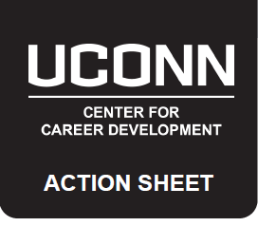
LEAD THE PACK PREP
LEAD THE PACK: JOB SHADOW WITH PRESIDENT HERBST
Applications for this program require candidates to submit a tailored cover letter and résumé. The search committee will evaluate résumés and cover letters submitted to ensure that they are specifically tailored for the Lead the Pack program and will take this into account when choosing finalists. The process in which these documents should be prepared is important as it should be followed for every job or development opportunity a candidate applies to in order to ensure the best chance of being invited for an interview.

PREPARE
In advance of writing and submitting a cover letter and résumé the following should be done:
- Research the opportunity to better understand the company culture and to identify buzz words
- Evaluate the job description to match your skills with skills being sought by the employer
- Identify the experiences that evidence those skills best
- Identify connections you have to the organization

Activity:
- Extract the skills & qualities sought by the employer. (2) Match them to your skills and experiences. (3) Provide evidence.

SKILLS EVIDENCE:
Cover Letter Basics:
- Tailored to a specific job announcement, follows a preset format
- Introduces the résumé
- Convinces the employer to invite you for an interview

Clearly states the following:
- How you found out about the opportunity
- Who you are and why you are writing
- Why you want the job and how you’re a fit
- Any connections you have to the company or opportunity
- _________________________________________________________

- _________________________________________________________

- _________________________________________________________

- _________________________________________________________

- _________________________________________________________

- ___________________________

- ___________________________

- ___________________________

- ___________________________

- ___________________________
Résumé Basics:
- Your résumé is a marketing tool
- It should be organized and grammatically correct
- It should be tailored for each specific use
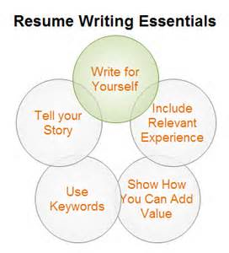

TAILORED DOCUMENTS
Résumé: (1) Includes an objective statement that is written specifically for the opportunity. (2) Is organized appropriately to match the skills & qualities desired. (3) Contains bullet statements that intentionally include skills & qualities listed in the job description.

Objective Statement: _________________________________________________________________________________________

___________________________________________________________________________________________________________

Sections of the Résumé: How will I organize my résumé to best highlight what the employer is looking for? List the order of sections for the résumé below.
___________________________________________________________________________________________________________
___________________________________________________________________________________________________________
___________________________________________________________________________________________________________

Action Verbs: List below action verbs to use within bullet statements that best highlight the skills being sought by the employer.

Cover Letter: (1) Contains appropriate contact information for the company and the correct date. (2) Establishes direct connections to the job posting by addressing the most sought after skills & qualities referenced in the job description. (3) Clearly states using language from research and the job description why you are a fit for the opportunity.

Establish a connection for the opening paragraph: How will you grab the reader’s attention?

Identify the key experiences to elaborate on in the cover letter: Expand on the key experiences listed within the résumé to “paint a picture” for the employer that evidences your skills & qualities.

___________________________________________________________________________________________________________
___________________________________________________________________________________________________________
___________________________________________________________________________________________________________

ACTION STEPS:
- Prepare tailored documents and vet them against the job description before submitting them
- Proofread, proofread and proofread
- Follow the application instructions exactly as listed
- Replicate this process for future career opportunities

LEAD THE PACK NEXT STEPS:
- Submit application materials via HuskyCareerLink by October 7th^{th}
- Finalists will be notified by October 11th and scheduled for interviews between October 12th and 19th
- Job Shadow date is TBD

